**Install And Configure SEO Checklist for Drupal**

The [SEO Checklist module](http://drupal.org/project/seo_checklist) is a useful list of recommended SEO best practices. It doesn't actually complete any work for you, but it does keep track of open and completed tasks. And best of all, it suggests SEO best practices to follow and other modules to install. Installation does require

### Step 1. Planning:-

The SEO Checklist is going to recommend a lot of potential modules for you to install. To help clarify things, I've divided those modules up into separate lists. You should start with the Base Modules list and then move on down to the others.

1. Base Modules
2. Optional Base Modules
3. Essential Working Modules.
4. Anti-Spam Modules. There are several possibilities but you only need to choose one.
5. Nice if you want them, but not really needed

A note of caution before we begin: not all of these modules have stable releases for Drupal 7. Please use of all these on a test site before using them on a live site.

### Step 2. Register for Webmaster Tools:-

Before you start you are going to want to do is register for Google, Yahoo and Bing accounts and sign up for their webmaster tools. You will need the verification files, tracking codes and other identifiers provided by these services.

1. Save the verification files to your hard disk.
2. Write down all account numbers.
3. Have your username and password to each account handy.

Every SEO program I've tested has needed this information, so if you're serious about SEO, start with signing up for the webmaster tools.

### Step 3: The Quickest Workflow for the SEO Checklist:-

The SEO Checklist will recommend a lot of modules for you to install, so here is one way to approach the installation:

First of all, open <http://drupal.org/project/seo_checklist>. Scroll down and look for “Downloads” section.

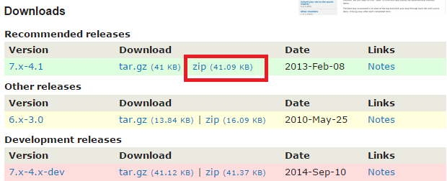

Copy link location for the zip file associated with installed drupal version.

Now, Open **“Modules” → “Install new module”** from drupal admin.

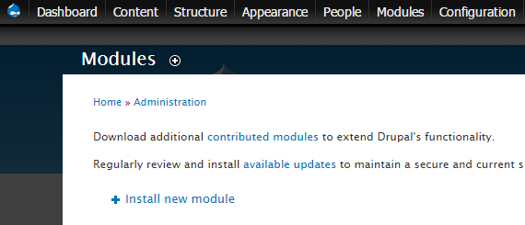

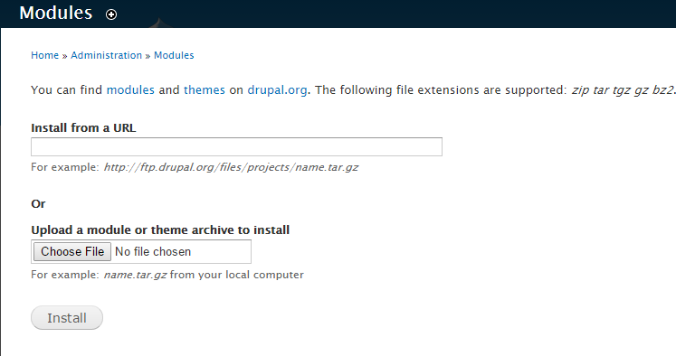

Paste the copied link in “Install from a URL” textbox.

Then, click on “Install” button.

Or

You can download module in zip format Than,

Browse for a downloaded module, choose it, then click Install.

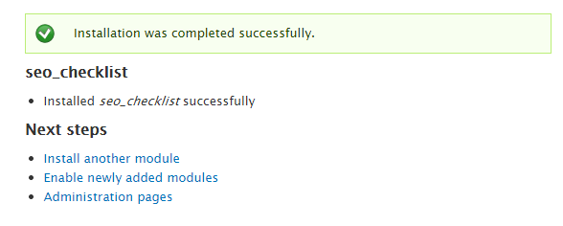

Click Enable newly added modules.

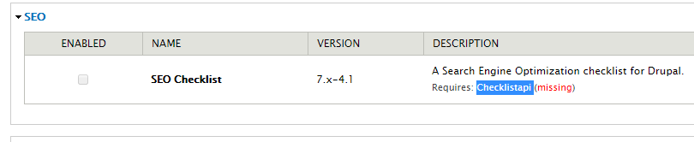

## To Enable this module You have to install Dependencies

Module [Checklistapi](https://www.drupal.org/project/checklistapi) by Following above Steps.

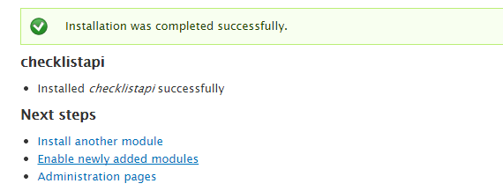

Click Enable newly added modules.

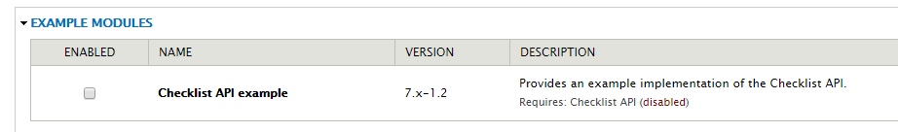

Enable Module by Clicking Checkbox.

Than After enable seo_checklist Module under SEO Title.

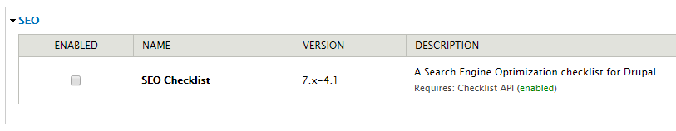

Normally what you would do is find the module you just installed and click the check box in the Enabled column, scroll to the bottom of the page and click Save to save the changes. Then you would see if there is a configuration link and fill in the details.

But you've got a lot of these to do so you might want to consolidate the tasks.

My actual work flow:

1. Installed all the modules
2. Enabled them in small groups
3. Ran a status report to check for errors
4. Corrected any errors
5. Got everything working before I configured them.

What I actually did to make this quicker was skip the Enable step, and go back to the top of the page and click **Install new module**again and installed another one. I kept installing until I was done.

Then I returned to the page and enabled them in bulk. If you do this, don't try to enable all of them at the same time. It stresses the system and you'll get errors. Enable a group and come back several times until they are all enabled.

Go to Reports > Status Report and check for errors. Just do the minimum amount of work you have to do to get rid of any errors.

Many of these modules are going to need configuration. I'll go back and consider the configuration as I go through the SEO Checklist. That's what it's for. It's going to take a lot of time and study if you're not already an SEO wizard to figure out the perfect configuration for everything.

Now we can click run cron manually and check for errors

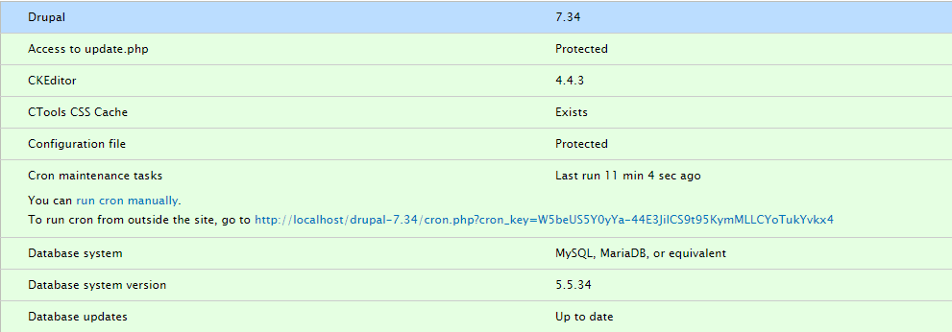

Just running cron will clear up some errors. You might have to take action on others.

Be sure to read the cautions too, and take action. The Status report will give you a good idea on what you need to do to fix things.

### Step 4. Install the base modules

Now let's get started with the installation. These modules are used by many other modules, and you may already have them installed. If not, you should install them now. They aren't really needed for SEO, but as you go through the checklist and try to install subsequent modules, you'll have to back up and install these too, so you might as well start here.

* **Ctools**    <http://drupal.org/project/ctools>
* **Context**     <http://drupal.org/project/context>
* **Token**    <http://drupal.org/project/token>
* **Clean URLs**Turn it on (part of core, just enable it)

### Step 5: Install the Optional base modules

The modules below are strictly optional and not absolutely essential to SEO. You can always skip these and come back to them if you don't think you need them now. But if you are going to want them, your life will be easier if you install them at this stage, rather than wait until they appear on the checklist.

**HTML Purifier**  
HTML Purifier is a standards-compliant HTML filter library. HTML Purifier will not only remove all malicious code (better known as XSS) with a thoroughly audited, secure yet permissive white list, it will also make sure your documents are standards compliant, something only achievable with a comprehensive knowledge of W3C's specifications.

This is a standalone component that strips improper HTML from entries. You need to download the entire compressed file and get special instructions on installation. It's an improvement on the filtered html core module, and isn't 100% necessary to optimization. It just depends on what level of optimization you wish to achieve.

* To install this you are going to need.
* The program [http://htmlpurifier.org](http://htmlpurifier.org/)
* HTML Purifier module <http://drupal.org/project/htmlpurifier>
* **Libraries API**    <http://drupal.org/project/libraries>

### Step 6. Install the Essential Working Modules For SEO

Now we come to the modules that actually do the optimizatin. If you've installed Ctools, Token and Context the rest should go pretty fast. The best and quickest workflow is to download, install and enable them, then configure them later as you go through the SEO Checklist.

* **Page Title Module**    <http://drupal.org/project/page_title>
* **Meta Tags** <https://www.drupal.org/project/metatag>
* **Module**    <http://drupal.org/project/pathauto>
* **Global Redirects**    <http://drupal.org/project/globalredirect>
* **Redirect Module**<http://drupal.org/project/redirect>
* **Google Analytics Module**    <http://drupal.org/project/google_analytics>
* **Google Analytics Tokenizer**http://drupal.org/project/ga_tokenizer
* **Google Analytics Contact Form**    <http://drupal.org/project/contact_google_analytics>
* **Context Keywords**    <http://drupal.org/project/context_keywords>
* **Meta Tags Quick**    <http://drupal.org/project/metatags_quick>
* **Scheduler Module**    <http://drupal.org/project/scheduler>
* **HTML Purifier Module**<http://drupal.org/project/htmlpurifier>
* **Site Verification Module**     <http://drupal.org/project/site_verify>
* **XML Sitemap Module**<http://drupal.org/project/xmlsitemap>
* **Site Map Module**    <http://drupal.org/project/site_map>
* **Search 404 Module**    <http://drupal.org/project/search404>
* **SEO Compliance Checker**    <http://drupal.org/project/seo_checker>
* **Read More Link**    <http://drupal.org/project/read_more>
* **AddThis**    <http://drupal.org/project/addthis>
* **Service Links Module**    http://drupal.org/project/service_links
* **AddAny Module**    <http://drupal.org/project/addtoany>
* **Facebook Social Plugins Integration**    http://drupal.org/project/fb_social
* **Follow**<http://drupal.org/project/follow>

It is Good to Install above Modules but not necessary to install all the modules at once. You can install Module as per your requirements or need.

You only need one of these. If may already have one installed. If not, you can choose any of these based on your preference.

* **Mollom**    <http://drupal.org/project/mollom>
* **Captcha Module**<http://groups.drupal.org/captcha>
* **Antispam Module**<http://drupal.org/project/antispam>

### Step 8. Nice if you want them, but not really needed

* **Administration Menu**<http://drupal.org/project/admin_menu>
* **Elements**<http://drupal.org/project/elements>
* **Security Review**<http://drupal.org/project/security_review>
* **Boost Module**<http://drupal.org/project/boost>

Now let's get started on the module itself.

### Step 9. Access the SEO Checklist

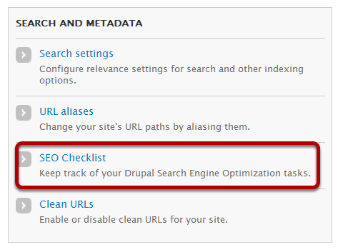

Scroll down the page to the Search and Metadata section and click on SEO Checklist. Scroll down the page to the Search and Metadata section and click on SEO Checklist.

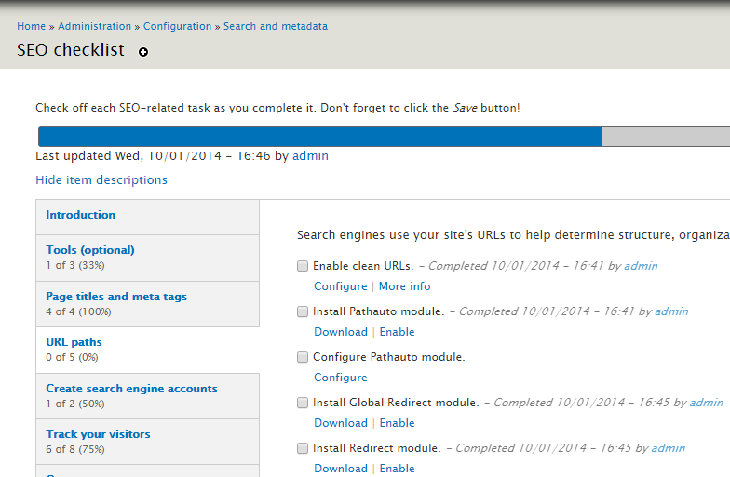

Move through the tabs on the left and check a box and Click Enable if you haven't enabled them yet.

The picture above shows what the list looks like before I installed the clean URLs, Pathauto, Global Redirect and Redirect modules. The download link actually takes you to the download page so you could download the module now, and then enable it. If you do it this way you will be working all day. Try the mass installation first.

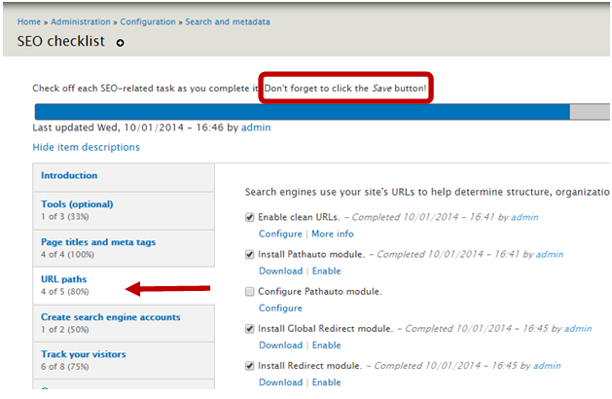

After I installed the Page Title Module you can see there is now a Configure link. If everything has been installed you will only need to work on configuration as you go through the list.

Each time you complete a task, click the check mark, then scroll to the bottom of the page and click the Save button.  
If you don't save, it won't record your check marks, and you won't have a record of what you did.

Keep going through all the tabs. Click the check boxes as you complete a task. Remember to save.

When you're all done you'll have a list of all the completed tasks, time and dates, who did the work, and quick access to the configuration so you can make changes.

This module will:

* Help you keep track of what needs to be done.
* Check for installed modules give you some basic information on them.
* Provide a list of things that need to go on your to-do list.
* Time/date stamp each item and record who completed it.